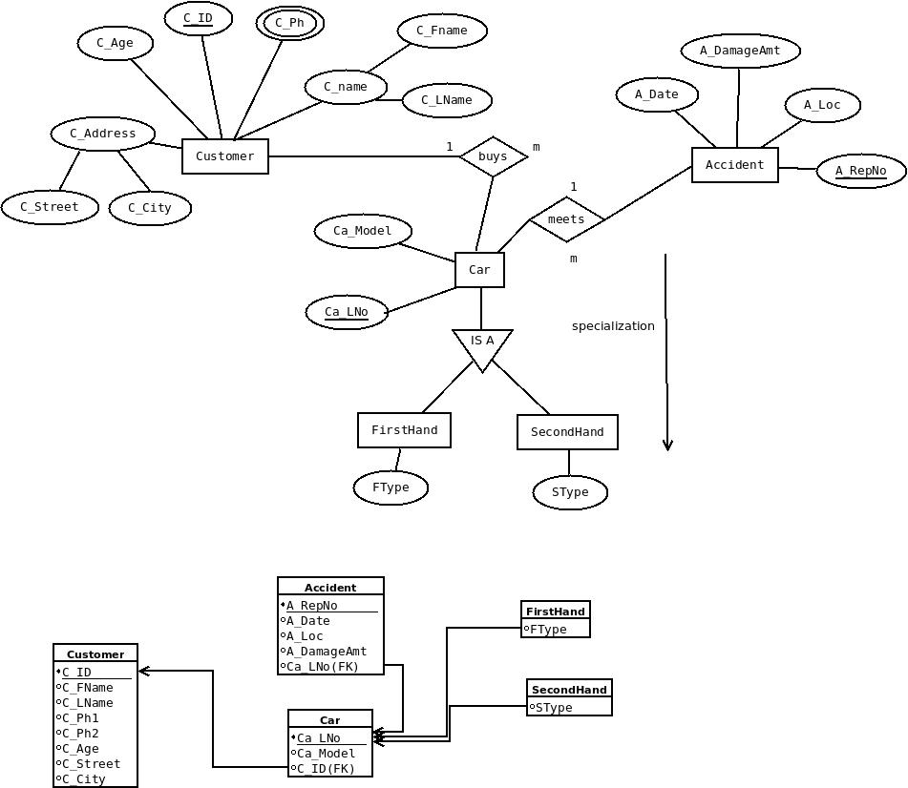

ASSUMPTIONS

1. A Customer can own more than one car. This indicates a one-to-many relationship between the `CUSTOMER` entity and the `CAR` entity, established by the `CID` attribute in the `CAR` table, which serves as a foreign key referencing the `CID` attribute in the `CUSTOMER` table.
2. A car can have multiple accidents. This indicates a one-to-many relationship between the `CAR` entity and the `ACCIDENT` entity, represented by the `LNO` attribute in the `ACCIDENT` table, which acts as a foreign key referencing the `LNO` attribute in the `CAR` table.
3. A car has a classification of cars with two subtypes: FirstHand and SecondHnad Car. The ER diagram can represent this using the IS A relationship feature.

CREATE TABLE CUSTOMER(
2 CID VARCHAR2(8) PRIMARY KEY CHECK(CID LIKE 'C%'),
3 NAME VARCHAR2(20) NOT NULL,
4 PHONE NUMBER(10) NOT NULL,
5 ADDRESS VARCHAR2(25) NOT NULL,
6 AGE NUMBER(2) NOT NULL
7 );

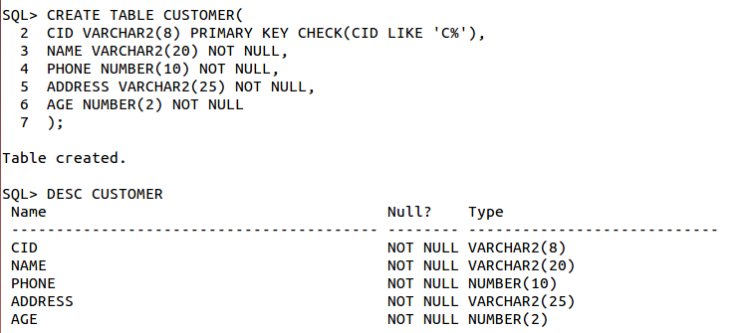

CREATE TABLE CAR(
2 LNO VARCHAR2(10) PRIMARY KEY,
3 MODEL VARCHAR2(15) NOT NULL,
4 CID VARCHAR2(8),
5 FOREIGN KEY(CID) REFERENCES CUSTOMER(CID) ON DELETE CASCADE
6 );

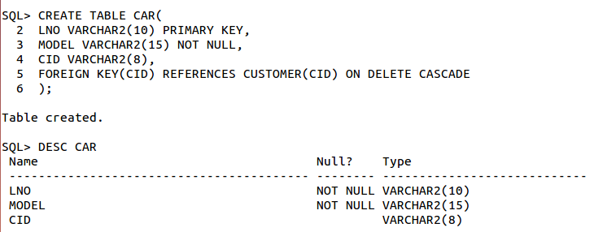

CREATE TABLE ACCIDENT(
2 REPNO VARCHAR2(10) PRIMARY KEY,
3 LOCATION VARCHAR2(20) NOT NULL,
4 DAMAGEAMT NUMBER(7,2) NOT NULL,
5 ADATE DATE,
6 LNO VARCHAR2(10),
7 FOREIGN KEY(LNO) REFERENCES CAR(LNO) ON DELETE CASCADE
8 );
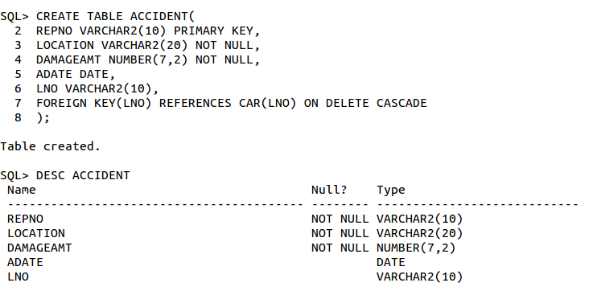
SQL> INSERT ALL
2 INTO CUSTOMER VALUES('C1','AMIT',8765458912,'KOL',20)
3 INTO CUSTOMER VALUES('C2','XYZ',9845678901,'MUM',30)
4 INTO CUSTOMER VALUES('C3','KOMAL',7658924567,'BEN',21)
5 INTO CUSTOMER VALUES('C4','ABC',6758945678,'DEL',40)
6 INTO CUSTOMER VALUES('C5','ABHI',8976578965,'KOL',28)
7 SELECT * FROM DUAL;

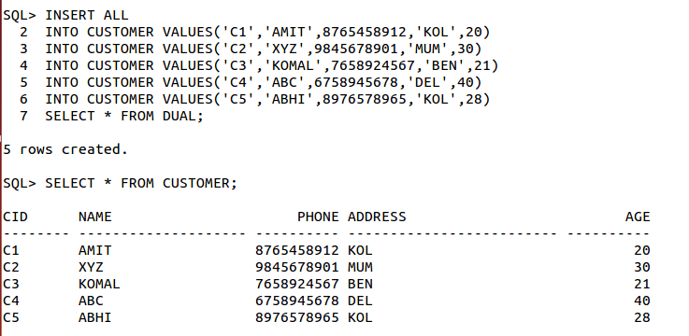
INSERT ALL
2 INTO CAR VALUES('AIBPC2010','XUV','C1')
3 INTO CAR VALUES('AIBD2011','NANO','C2')
4 INTO CAR VALUES('AIDD2009','BDP','C3')
5 INTO CAR VALUES('BGAJ2003','SCORPIO','C4')
6 INTO CAR VALUES('GTEU1827','XUV','C5')
7 SELECT * FROM DUAL;
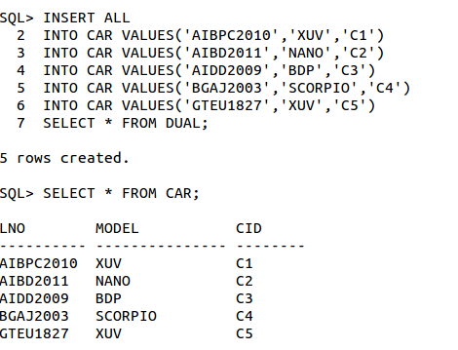

INSERT ALL
INTO ACCIDENT VALUES('FIR271','KOL',5000,TO_DATE('19-03-2011','DD-MM-YYYY'),'AIBPC2010')
INTO ACCIDENT VALUES('FIR150','MUM',1000,TO_DATE('21-05-2010','DD-MM-YYYY'),'AIBD2011')
INTO ACCIDENT VALUES('FIR250','BEN',2000,TO_DATE('15-06-2020','DD-MM-YYYY'),'AIDD2009')
INTO ACCIDENT VALUES('FIR101','DEL',10000,TO_DATE('12-10-2008','DD-MM-YYYY'),'BGAJ2003')
INTO ACCIDENT VALUES('FIR200','KOL',1200,TO_DATE('28-03-2023','DD-MM-YYYY'),'GTEU1827')
SELECT * FROM DUAL;
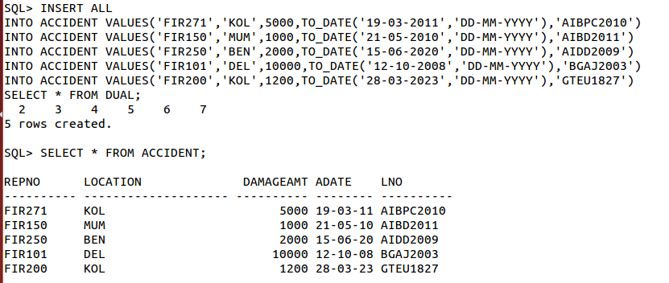
SELECT COUNT(C.CID) FROM CUSTOMER C
2 JOIN CAR CA ON CA.CID=C.CID
3 JOIN ACCIDENT A ON A.LNO=CA.LNO
4 WHERE EXTRACT(YEAR FROM A.ADATE)=2010;

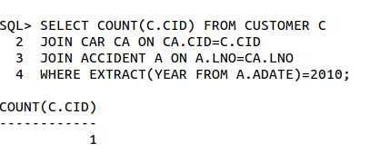

SELECT COUNT(*) AS TOTAL
2 FROM ACCIDENT A
3 JOIN CAR CA ON A.LNO=CA.LNO
4 JOIN CUSTOMER C ON CA.CID=C.CID
5 WHERE C.NAME='XYZ';

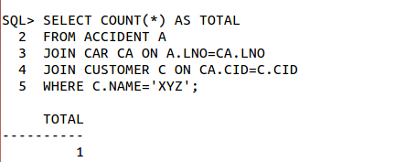

INSERT INTO ACCIDENT VALUES('FIR111','MUM',8000,TO_DATE('15-10-2021','DD-MM-YYYY'),'GTEU1827');

1 row created.

SQL> COMMIT;
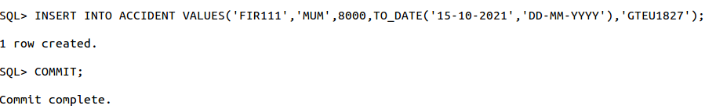
DELETE FROM CAR WHERE MODEL='SCORPIO' AND CID='ABC';

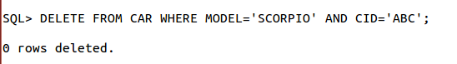

SQL> UPDATE ACCIDENT
2 SET DAMAGEAMT=5000
3 WHERE REPNO='FIR200' AND LNO='GTEU1827';

